ITRW 212 – 11 May 2017
Assignment 2
Unzip and open the Java program called SearchSortFriends.
The Friends text file contains information about friends in the following format:
Name and surname, age,cell number
Sue Peterson,23,0845367889
John Mokoena,22,0723456771
Elizabeth Gaba,24,0834235667
Frank Smith,21,0723456970
And so on.
The Friend object class contains code for the attributes and methods of a Friend object.
The GUI class contains code to display the GUI but the buttons contain no code to perform any useful tasks.
Do the following:
Write a Data class with methods to do the following:
readData:
This must be a void method.
Read data from the text file into an array that will keep Friend objects.
sortData:
It must be a void method. Sort the content of an array according names in alphabetical order.
getCount:
Return the number of elements in the array
getArray:
Return the array
In the GUI class:
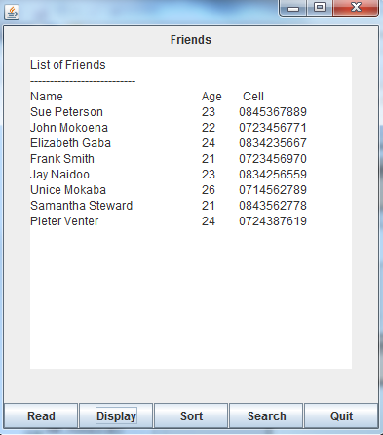
Write code for the buttons:
Read:
Call the method to read the data from the text file into the array.
Display:
Display a heading, subheadings and the name, age and cell number of all the friends using the toString() method.
Sort:
Call the method to sort the data.
Search:
Ask the user to enter a name.
Call the method to look up the name. Display a suitable message.

Look up a name:
